24.29: a) 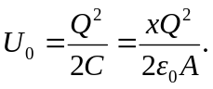
b) Increase the separation by 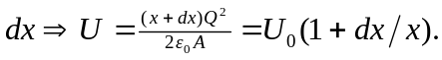 The change is then 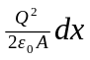.
c) The work done in increasing the separation is given by:
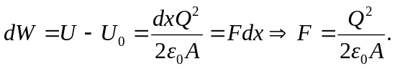
d) The reason for the difference is that E is the field due to both plates. The force is QE if E is the field due to one plate is Q is the charge on the other plate.

